Chapter 12, Solution 78.

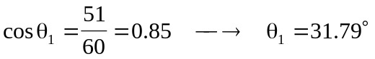

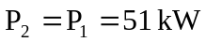
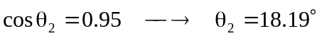
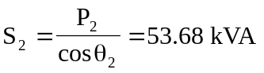
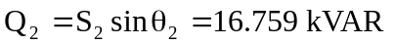

For each load,
